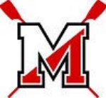

**McLean High School Crew HARDWOOD MULCH SALE!**

**Scan QR Code or visit: https://www.mcleancrew.org/**



**Rower Name: ______**

***High-Quality Double-Shredded HARDWOOD MULCH in Large 3 cu ft bags***

**FREE delivery March 1st-2nd** (March 15th-16th in case of inclement weather)

**Orders due by February 17th**

***Delivery address must be in zip codes 22101, 22102, 22182, 22043, 22046. Only one delivery address per order allowed. No split deliveries. 10 bag minimum.***

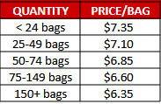

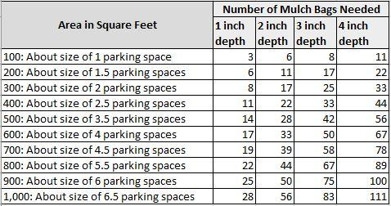

***Thank you! Your support keeps us winning on the water!***