3rd Annual Turkey Trot Sponsorship Request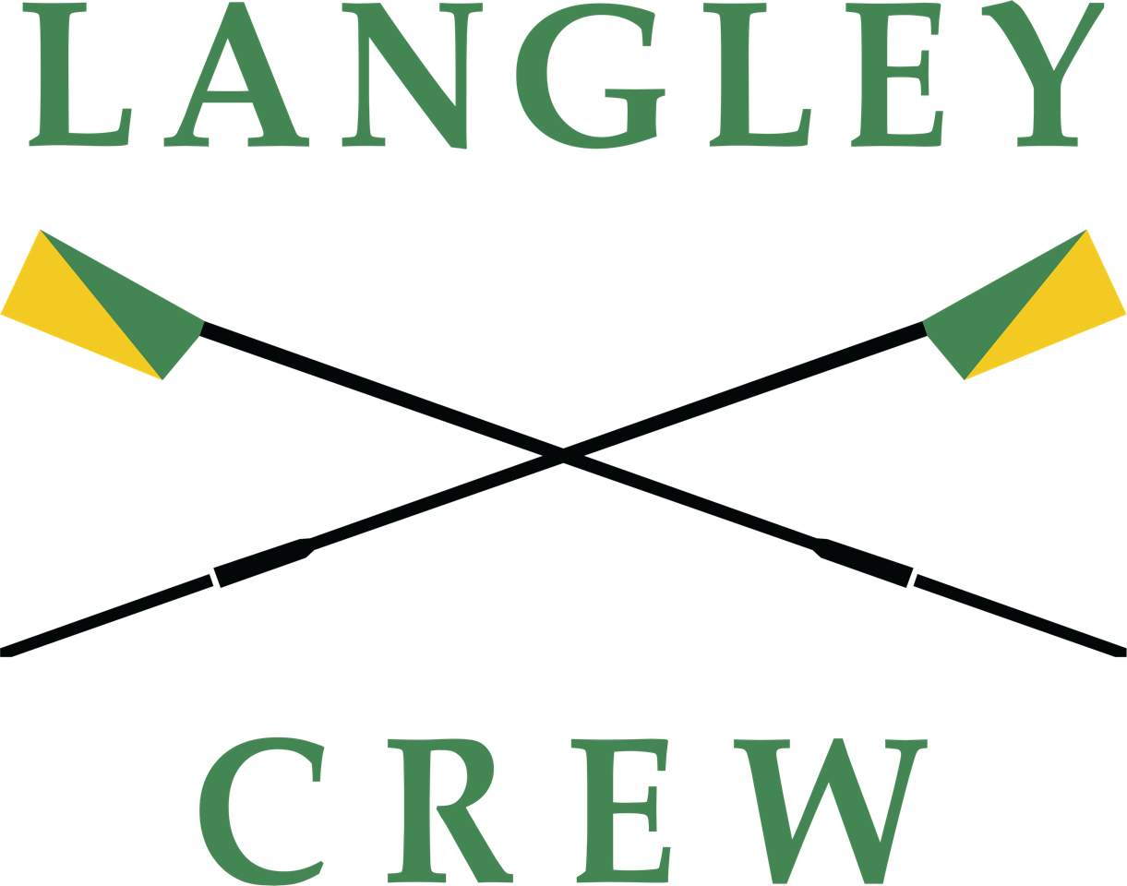 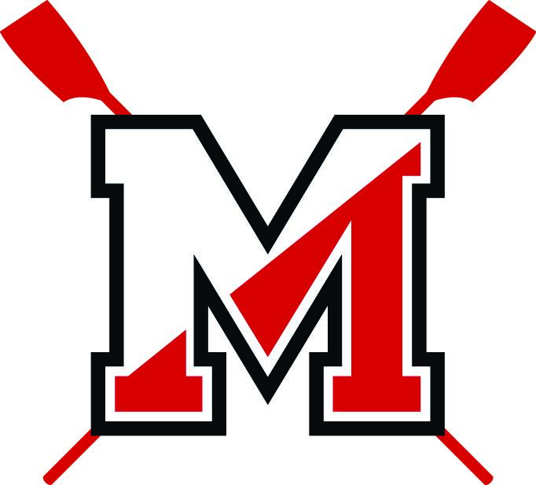

Langley Crew Club and McLean Crew Club, of Langley and McLean High Schools, are temporarily putting aside their friendly rivalry and collaborating for this year’s Turkey Trot 5K. It is hoped that this demonstration of unity will strengthen both programs, now and into the future.

Because crew is considered a club sport, Langley Crew Club and McLean Crew Club receive no funding from the state, county, or school. To qualify as an “official” sport, the activity must have participation from more than 50 percent of Virginia high schools. Crew is gaining in popularity but requires a heavy financial commitment to pay for boats, equipment, coaching fees, and transportation to regattas and training venues. It falls to the athletes’ families to pay most of these costs. Our objective is to gain sufficient support from you, our community and corporate sponsors, so that financial limitations will not prevent a student from competing.

Your financial support in the form of a tax-deductible donation will be shared equally amongst both clubs and allow the teams to continue providing this competitive athletic opportunity to students in our community. The athletes and their families appreciate every dollar donated, and all expenses are vigorously discussed and approved by both governing Board of Directors for Langley Crew and McLean Crew Clubs.

**Langley and McLean teams:**

* **Receive NO financial support from the state, county or school district. Our teams’ expenses—all equipment, boats, coaches, insurance, and buses to our regattas and practices—are paid for by parents and donations!**
* **Your tax-deductible donation will provide valuable support for these competitive and highly successful athletic teams.**

ABOUT THE TEAMS:

**Langley Crew** celebrated its 32nd anniversary during the 2024 season. Our team is possibly the largest Scholastic Crew Club in the Northern Virginia area with more than 120 scholastic members and growing. Langley Crew is diverse and inclusive; our 504 mandate of inclusion, our No Cut Policy, and coaches’ dedicated efforts to give all members the opportunity to race in regattas during the spring water season. Langley Crew is a top competitive rowing club with a decade of medal finishes in our Virginia State championships, competitive performances in Regional Championships such as Manny Flicks and National races such as SRAA and Stotesbury, with athletes who go on to receive rowing scholarships and compete at the collegiate and National Level.

**Langley Crew Boosters Club, Inc. is a not-for-profit, 501(c)(3) Organization Our Federal Tax ID # is 54-1655714**

**McLean Crew Club** celebrated its 27th anniversary during the 2024 spring season. The club promotes and operates the rowing program at McLean High School and annually enrolls about 90 student athletes. It is recognized for top-quality coaching staff, dedicated athletes, and success, winning many medals over the years. McLean Crew has produced athletes who moved on to compete in national championships, world championships, and the Olympic Games. We find that the students who participate in crew learn critical life lessons such as hard work, endurance, grit, teamwork, and commitment. Crew challenges minds and bodies in extraordinary ways, grows confidence, and supports physical and mental wellbeing. To support all students who wish to row, McLean Crew Club offers need-based scholarships.  
**McLean Crew Club, Inc. is a 501(c)(3) organization. Our Federal Tax ID # is 54-1834730**

**All donations are tax deductible as allowed by law. No goods or services were provided in exchange for contributions.**

SPONSORSHIP

Sponsors receive **DOUBLE** recognition - each team recognizes these levels and shares the donation equally.

LEVELS AND BENEFITS RECEIVED:

**Trot Sponsor -** $300, Sponsor logo on Turkey Trot shirt and Sponsor name listed on teams’ websites

**Rower Sponsor** - $500, Same as Trot Sponsor and Sponsor website link on teams’ websites

**Seat Sponsor** - $1,000, Same as Rower Sponsor, Team photos to display, and Sponsor logo on teams’ websites and monthly newsletter sent to rowers and their families

**Boat Sponsor** - $2,500, Same as Seat Sponsor, Optional Booth Space at Turkey Trot, Sponsor Banner displayed at regattas, AND official custom Langley and McLean Crew oar blades with business name inscribed to display.

Sponsorship Donations: <https://www.mcleancrew.org/online-store/Tax-Deductible-Donation-to-McLean-Crew-Turkey-Trot-2024-p701736152>



Register to Run/Walk: <https://potomac.enmotive.com/events/register/2024-langley-crew-turkey-trot-5k>

